**YOUTUBE VIDEO DOWNLOADER**

Project submitted to the

SRM University – AP, Andhra Pradesh

Submitted in partial fulfilment of the requirement for the award of the degree of

**Bachelor of Technology**

**in**

**Computer Science and Engineering**

**School of Engineering and Sciences**

Submitted By

Abhinay Pratap Singh

AP21110010852

Under the guidance of

**Prof. Poonam Yadav**



# Department of Computer Science and Engineering

**SRM University, AP**

**Neerukonda, Mangalagiri, Guntur**

**Andhra Pradesh – 522 240 [Month, Year]**

# Department of Computer Science and Engineering

SRM University, Andhra Pradesh



**CERTIFICATE**

This is to certify that the Project report entitled **“Youtube Video Downloader”** is being submitted by **Abhinay Pratap Singh (AP21110010852),** a student of Department of Computer Science and Engineering, SRM University, AP, in partial fulfilment of the requirement for the degree of **“B.Tech (CSE)”** carried out by he r/his during the academic year 2021-2022.

|  |  |
| --- | --- |
| Signature of the Supervisor | Signature of Head of the Dept. |
| Prof. Poonam Yadav | **JATINDRA KUMAR DASH** |

# Acknowledgement

The satisfaction that accompanies the successful completion of any task would be incomplete without introducing the people who made it possible and whose constant guidance and encouragement crowns all efforts with success.

I am extremely grateful and express my profound gratitude and indebtedness to my project guide, **Ms. Poonam**, Lecturer, Department of Computer Science & Engineering, SRM University, Andhra Pradesh, for her kind help and for giving me the necessary guidance and valuable suggest user can get weather conclusions of the place he enters

**Introduction**:

YouTube is a very popular video-sharing website. Downloading a video’s/playlist from YouTube is a tedious task. Downloading that video through Downloader or trying to download it from a random website increases the risk of licking your personal data. Using the Python Tkinter package, this task is very simple-efficient-safe.

**Prerequisites**:

* Used Tkinter. It is a standard GUI library and it is one of the easiest ways to build a GUI application.

* Pytube used for downloading videos from youtube.

**Algorithm**:

STEP1: START

STEP2: Required libraries are imported like tkinter and pytube.

STEP3: Create GUI.

STEP4: take link name as input.

STEP5: Create link entry.

STEP6: Browse your path

STEP7: Enter your resolution entry.

STEP8: Create download button.

STEP9: Create download function.

STEP10: END

**CODE:**

# Importing necessary packages

import tkinter as tk

from tkinter import *

from pytube import YouTube

from tkinter import messagebox, filedialog

# Defining CreateWidgets() function to create necessary tkinter widgets

def Widgets():

    head_label = Label(root, text="YouTube Video Downloader Using Tkinter",

                    padx=15,

                    pady=15,

                    font="SegoeUI 14",

                    bg="palegreen1",

                    fg="red")

    head_label.grid(row=1,

                    column=1,

                    pady=10,

                    padx=5,

                    columnspan=3)

    link_label = Label(root,

                    text="YouTube link :",

                    bg="salmon",

                    pady=5,

                    padx=5)

    link_label.grid(row=2,

                    column=0,

                    pady=5,

                    padx=5)

    root.linkText = Entry(root,

                        width=35,

                        textvariable=video_Link,

                        font="Arial 14")

    root.linkText.grid(row=2,

                    column=1,

                    pady=5,

                    padx=5,

                    columnspan=2)

    res_label = Label(root,

                    text="  Resolution : ",

                    bg="salmon",

                    pady=5,

                    padx=5)

    res_label.grid(row=4,

                    column=0,

                    pady=5,

                    padx=5)

    root.resText = Entry(root,

                        width=35,

                        textvariable=video_res,

                        font="Arial 14")

    root.resText.grid(row=4,

                    column=1,

                    pady=5,

                    padx=5,

                    columnspan=2)

    foot_label = Label(root, text="*Enter any one of 144, 360,720 in Resoltion",

                    padx=5,

                    pady=5,

                    font="SegoeUI 10",

                    bg="palegreen1",

                    fg="red")

    foot_label.grid(row=6,

                    column=0,

                    pady=10,

                    padx=5,

                    columnspan=3)

    destination_label = Label(root,

                            text="Destination :",

                            bg="salmon",

                            pady=5,

                            padx=9)

    destination_label.grid(row=3,

                        column=0,

                        pady=5,

                        padx=5)

    root.destinationText = Entry(root,

                                width=27,

                                textvariable=download_Path,

                                font="Arial 14")

    root.destinationText.grid(row=3,

                            column=1,

                            pady=5,

                            padx=5)

    browse_B = Button(root,

                    text="Browse",

                    command=Browse,

                    width=10,

                    bg="bisque",

                    relief=GROOVE)

    browse_B.grid(row=3,

                column=2,

                pady=1,

                padx=1)

    Download_B = Button(root,

                        text="Download Video",

                        command=Download,

                        width=20,

                        bg="thistle1",

                        pady=5,

                        padx=15,

                        relief=GROOVE,

                        font="Georgia, 13")

    Download_B.grid(row=5,

                    column=1,

                    pady=20,

                    padx=20)

# Defining Browse() to select a destination folder to save the video

def Browse():

    # Presenting user with a pop-up for directory selection. initialdir

    # argument is optional Retrieving the  user-input destination directory and

    # storing it in downloadDirectory

    download_Directory = filedialog.askdirectory(

        initialdir="YOUR DIRECTORY PATH", title="Save Video")

    # Displaying the directory in the directory

    # textbox

    download_Path.set(download_Directory)

# Defining Download() to download the video

def Download():

    # getting user-input Youtube Link

    Youtube_link = video_Link.get()

    # select the optimal location for saving file's

    download_Folder = download_Path.get()

    video_resolution = video_res.get()

    if video_resolution=="360":

        res=18

    elif video_resolution=="720":

        res=22

    elif video_resolution=="144":

        res=17

    # Creating object of YouTube()

    getVideo = YouTube(Youtube_link)

    # Getting all the available streams of the youtube video and selecting the first from the

    videoStream = getVideo.streams.get_by_itag(res)

    # Downloading the video to destination directory

    videoStream.download(download_Folder)

    # Displaying the message

    messagebox.showinfo("SUCCESSFULLY",

                        "DOWNLOADED AND SAVED IN\n"

                        + download_Folder)

# Creating object of tk class

root = tk.Tk()

# Setting the title, background color and size of the tkinter window and disabling the resizing property

root.resizable(False, False)

root.title("YouTube Video Downloader")

root.config(background="PaleGreen1")

# Creating the tkinter Variables

video_Link = StringVar()

download_Path = StringVar()

video_res = StringVar()

# Calling the Widgets() function

Widgets()

# Defining infinite loop to run application

root.mainloop()

**Output:**

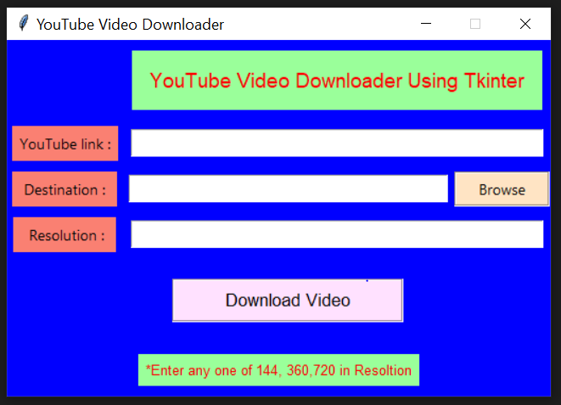

**Conclusion:**

Finally, I have used my knowledge I have learnt till the date in order to create this. This can be helpful to download the youtube video.